**Task 15: Investigate and resolve an AKS issue where pods cannot communicate with external services.**

**Expected Output:** Description of the issue and resolution steps (network-issue-resolved.md).

* **Description of the issue**

I deployed an Nginx application on an AKS cluster using a deployment yaml and a service yaml. The service is exposed using a LoadBalancer to allow external access.

To manage external traffic, I also configured an NGINX Ingress controller. however, when I tried to access the application using curl, I did not receive any response.

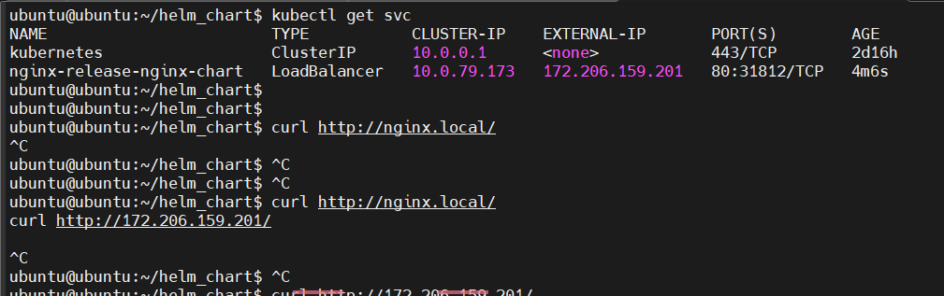

* **Resolution steps:**
* After thoroughly debugging all configuration files and using the **kubectl describe** command on the Ingress resource and service yaml, I discovered that there was a mismatch in the labels between the deployment yaml and service yaml. This mismatch caused the application to be inaccessible.
* Since kubernetes services use labels and selectors to route traffic to the correct pods, the label mismatch prevented the service from correctly forwarding requests to the deployed nginx pods. As a result, external access to the application was failing, and curl requests were not receiving a response.
* To resolve the issue, I modified the Ingress yaml file and updated the labels to match those defined in the deployment yaml and service yaml. after making these corrections, I reapplied the Ingress resource using below command.
* once the Ingress configuration was successfully updated and applied, the service became reachable externally. I verified the fix by running a curl command, which successfully returned the expected response from the Nginx application.

$ kubectl apply -f ingress.yaml

$ echo "172.206.159.201 nginx.local" | sudo tee -a /etc/hosts



$ curl <http://nginx.local/>

